Let’s assume that we have given this dataset:
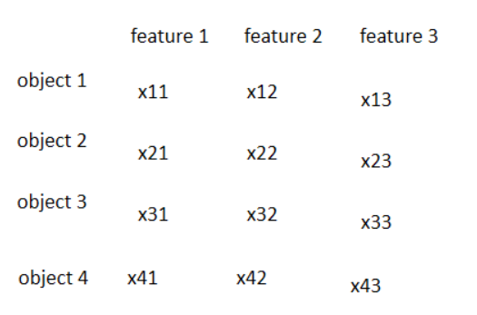

- At first we check which object is the most similar to the object 1.
- Then we check which object is the most similar to the object 2, 3 and so on
- In this way we obtain different pairs of similar objects. Now out of those pairs we choose this pair which is the most similar. This is our cluster 1
- Now we go back to the first step but this time we treat the new cluster as a single object

Let’s assume that we assigned object 1 and object 2 to the cluster 1. So the next iteration would look like this:
- Find the most similar object to the cluster 1
- Find the most similar object to the object 3
- Find the most similar object to the object 4
- Out of created pairs choose the most similar one and create cluster 2

In order to check how similar are objects we can use for example the Euclidian distance.

We can draw a dendrogram to visualize our clusters:
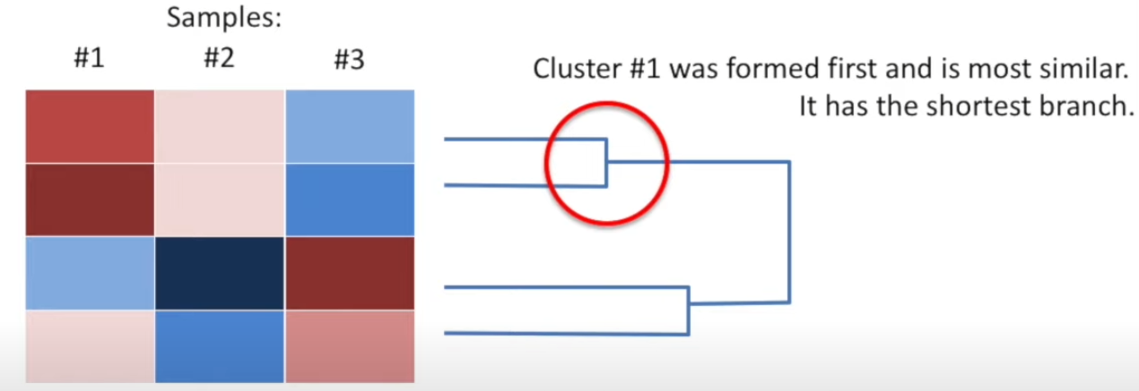
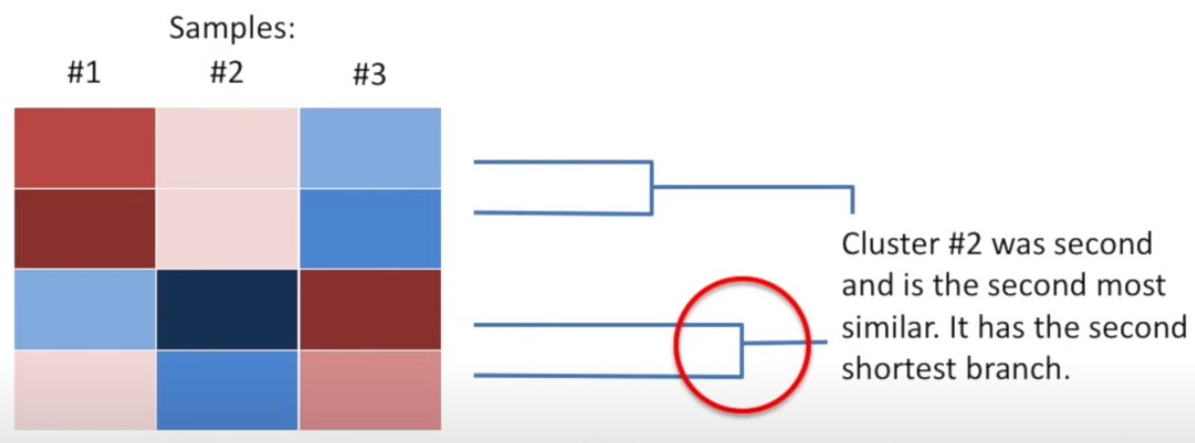
Branches indicates clusters. The longer branch, the less similar is the cluster.

